**Attendance convening**

Why We Drop Out – book by UW Tacoma faculty – very relevant for our communities.

FBA for Absenteeism and Truancy from Safe and Civil Schools.



Elements of Success of MTSS for Attendance

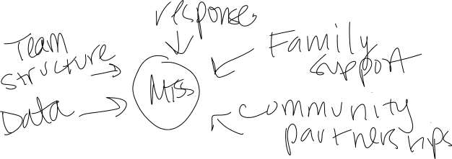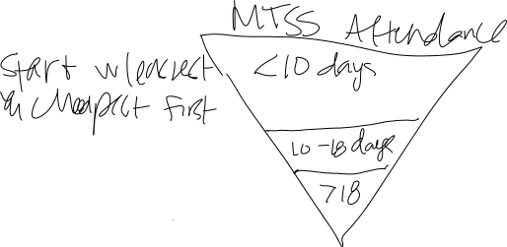

Selah Attendance

* Use data

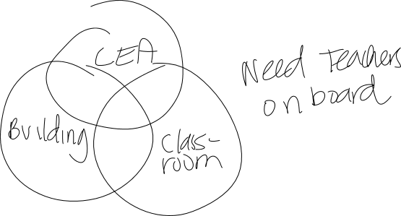

At the district level they changed their board policy to comply with the law, added staffing supports (hired 2 staff) and provided PD to educate staff.

At the building Level they focused on complying with the board policy/law. Looking at excused and unexcused absence – calling parents and conferencing with them by phone as soon as they get them on the line (with the exception of 504/IEP students which require the team).

Lead measures – setting weekly attendance goals on Fridays with the kids. Making attendance announcements and having prizes.

Lag measures – success plans from attendance works.

Log every call in their SIS with notes and that creates a history that folks can see from year to year.

Educate the community, staff and parents – flyers in multiple languages, handbook, parent phone calls for at-risk and chronic absenteeism, creating success plans (Sample letter attached)

Monitor the data – specifically looking for patterns and trends with a team that includes staff such as school nurse/counselors who have a pulse on the families. Follow up on each absence for any student who falls within tier 3. Start the school year with a watch list of students who have had issues in the past.

Creating systems – MTSS, support staff, attendance team, interventions and incentives

Attendance team – counselor, FACE, AP and Nurse

* Counselors teach an attendance group as a Tier 3 intervention – small group incentives, teaching them about why students are at school.

What are ways that you support elementary schools to address attendance?

* Trying to connect with the parents. Having a crossing guard walk a little farther to meet the students right by their apartments, for students with chronic illness working with the parents to have the student see the school nurse.
* Attendance contracts – lays out what parents can excuse.
* Training and support for office staff
* Community partners for elementary – common voices, the Y will start a class for parents.
* The younger the students were that went to CTB the better the outcomes.
* By getting to know the kids better, you can get the the root cause better.
* Kids want to come to school on the days that they had high interest electives such as weather, sign-language, etc.
* Family engagement

Thurston County

* Nudge post-cards
* Signs from attendance works – September is attendance awareness month
* Truancy workshop
* Robocall with Seahawks
* Door hangers for home visits
* A teacher made a video on why to attend school
* After 10 excused absences, they require a doctor’s notes

Yakima

* Got attendance posters at every community organization and even stores
* Admins and counselors go out to meet kindergarteners at before the school year.
* Standardize a common set of expectations and systematize the process
* Building huddles
* Check and connect – there is a curriculum (requires training) – they have four check and connect mentors.

Vancouver

* Made an attendance screen saver mandatory for any school iPad and computer. The school is 1-to-1 so all the students saw this.
* Implemented a campaign on all social media platforms.
* Attendance celebration – called the prize patrol. Incentives for students and teachers
* Principals toolkit – resources and data around attendance. This included data from a survey
* Each school has an attendance team that meets weekly.
* Pre-petition interventions – field attendance specialists (part-time) – meeting with students before their 4th unexcused absence, give the assessment (not WARNS), then the student is connected with resources, run a withdrawn list each week to work on re-engagement. Card with all the options for school/graduation. There is a referral form for students to be referred before they drop out.