WA Charters Member Service
SafeSchools & Exceptional Child
Access
WA Charters has contracted with SafeSchools for health, safety and instructional trainings. To access, visit the True Measure Collaborative page on the WA Charters website. Click on the SafeSchools logo to be directed to login.
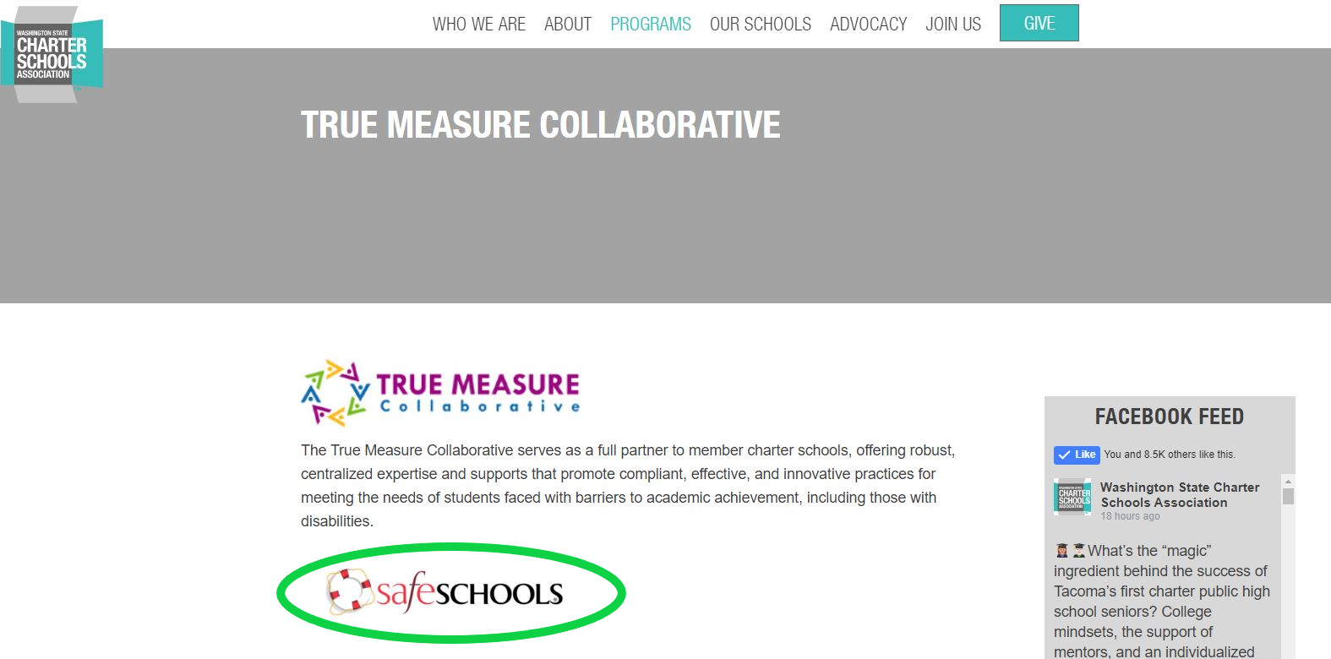
Alternatively, you can input the URL directly: https://wacharters-wa.safeschools.com/login
Employee Log In
To log in, use your school employee email address as your username. You will be prompted to confirm your name and title. No password is required.
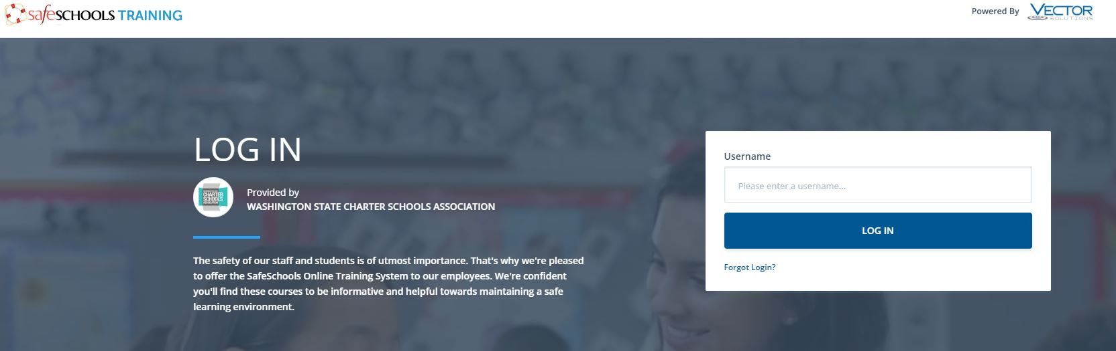
Admin Log In
For staff who have been assigned administrative permissions, you will be prompted in input a password which is the first 4 letters of your username. Once you’re in the system, you can set a more secure password.
Employee Training Site
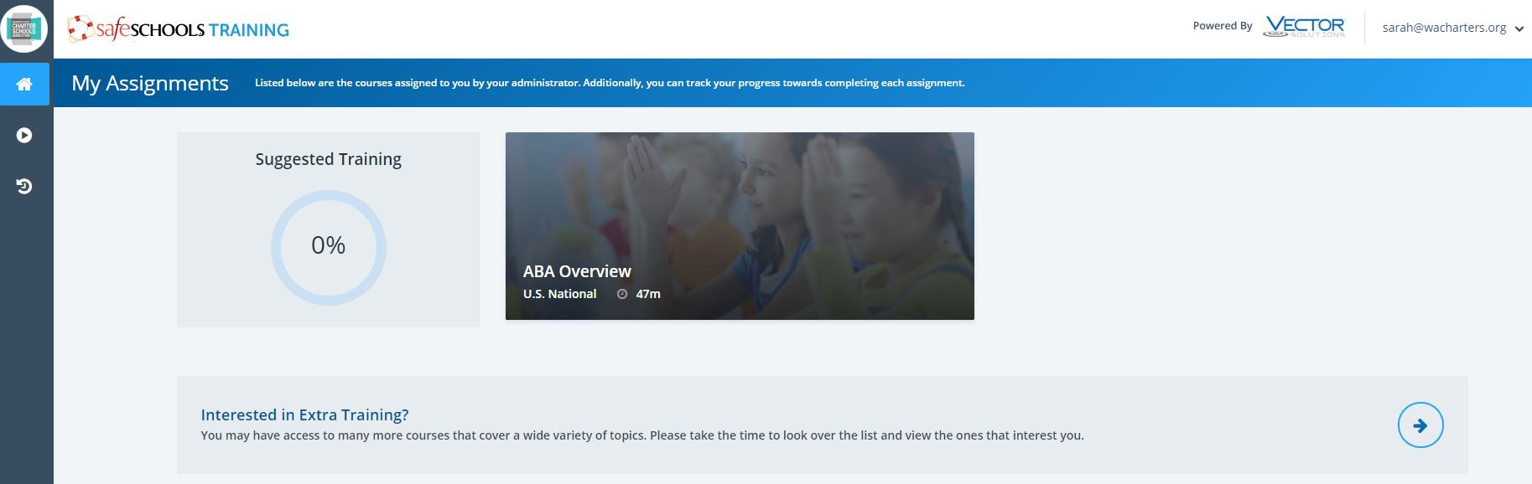
Once logged in, employees will see any trainings that have been assigned as either suggested or mandatory. If they have started a training, their training progress will be listed. Staff members who are interested in self-assigning Exceptional Child trainings can do so by clicking “Interested in Extra Training” and choosing the training they would like to add.
Administrative Site
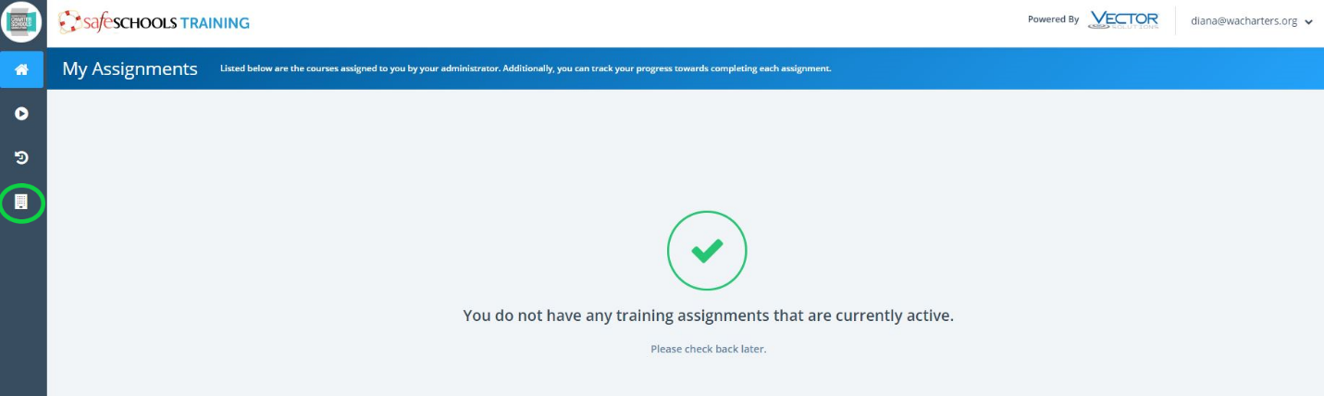
For employees with administrative permissions, an additional square icon will be visible on the left vertical panel. To assign trainings and run reports, click that icon.
Click here for the Training Administrators Quick Guide.
To schedule assistance in setting up your training plans, email Diana Marker at diana@wacharters.org.
Available Trainings
- SafeSchools
- Exceptional Child

